Access Control Policy - Framework Document

PG Cybersecurity Program – Access Control Policy Framework Document

Organization Name : PG Cybersecurity Program
Document Owner : Data Defenders (Project Group-8)

Approved By :
Role :
Signature :
Date :

Abstract
This document presents a comprehensive Access Control Policy Framework designed for large enterprise environments. It establishes a clear policy hierarchy, governance structure, and enforceable controls covering authentication, authorization, identity lifecycle management, and access review. The framework aligns with global security standards and verified industry research while distinguishing validated findings from original analysis, ensuring both regulatory compliance and operational effectiveness.

Table Of Contents
- Executive Checklist (What This Document Will Do)
- Document Structure Overview
- Purpose, Scope, and Audience
- Access Control Policy Hierarchy Framework
- Access Control Policy (Top-Level)
- Access Control Standards
- Access Control Procedures
- Access Control Guidelines
- Governance Model
- Review, Audit, and Continuous Improvement
- Enforcement and Non-Compliance
- Modern Workplace Considerations
- Research Classification
- References

Keywords
Access Control, Identity and Access Management (IAM), Authentication, Authorization, Governance Risk and Compliance (GRC), Policy Framework, Least Privilege

1. Executive Checklist (What This Document Will Do)
- Establish a formal policy hierarchy (Policy → Standards → Procedures → Guidelines) specific to Access Control
- Define governance, ownership, approval, and review mechanisms aligned with GRC best practices
- Integrate authentication, authorization, and access review requirements into a unified control framework
- Ground recommendations in verified research from global enterprises and financial institutions
- Distinguish validated research findings from original analysis and commentary
- Balance security rigor with operational and business enablement

2. Document Structure Overview
- Purpose, Scope, and Audience
- Policy Hierarchy Framework
  - Definitions and relationships
  - Governance ownership at each level
- Access Control Policy (Top-Level Policy)
- Supporting Standards (Authentication, Authorization, Identity Lifecycle)
- Procedures (Operational Execution)
- Guidelines (Contextual & Adaptive Controls)
- Governance Model
  - Roles and responsibilities
  - Approval and escalation paths
- Review Cycles, Audit, and Continuous Improvement
- Enforcement and Non-Compliance Handling
- Modern Workplace Considerations (BYOD, Remote Work, AI Tools)
- Verified Research vs Original Commentary
- References

3. Purpose, Scope, and Audience

3.1 Purpose
This framework defines how access to information systems, applications, data, and infrastructure is requested, approved, provisioned, reviewed, and revoked in a large enterprise environment.

3.2 Scope
Applies to:
- Employees, contractors, third parties, and service accounts
- On-premises, cloud, and hybrid systems
- Human and non-human identities

3.3 Audience
- Security Architects and Engineers
- IAM and PAM Specialists
- CISOs, Information Security Managers
- Compliance Officers and Policy Analysts
- Academic reviewers and professors
Validation: Scope and audience are explicitly defined.
Next Step: Establish the policy hierarchy that governs all subsequent controls.

4. Access Control Policy Hierarchy Framework

4.1 Purpose of Diagram
Purpose: Visualize relationships and authority flow across policy artifacts
Minimum Inputs: Organizational governance model, risk appetite, regulatory scope
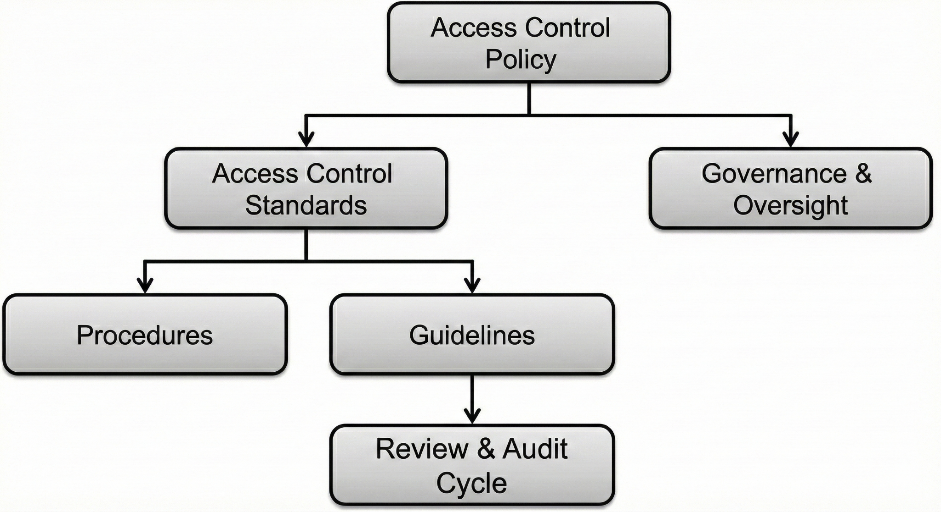

4.2 Hierarchical Levels Explained
Level | Purpose | Authority | Change Frequency
Policy | States mandatory organizational intent | Board / Executive | Low
Standards | Define enforceable security requirements | CISO / Security Council | Medium
Procedures | Describe operational execution | Security Operations | High
Guidelines | Provide recommended practices | Advisory | As needed
Verified Research:
This hierarchy aligns with ISO/IEC 27001 control documentation structure and NIST SP 800-53 governance layering [1][2].
Original Commentary:
Clear separation prevents policy dilution while allowing operational agility without executive re-approval.
Validation: Hierarchy is explicit, complete, and governance-aligned.
Next Step: Define the Access Control Policy itself.

5. Access Control Policy (Top-Level)

5.1 Policy Statement
Access to organizational information assets shall be granted based on verified identity, explicit authorization, and business necessity, and shall be reviewed periodically.

5.2 Core Policy Principles
- Least Privilege
- Need-to-Know
- Separation of Duties (SoD)
- Zero Trust Alignment

5.3 Mandatory Requirements
- All access must be authenticated using approved mechanisms
- All access must be authorized via documented role or entitlement models
- All access must be reviewed, recertified, or revoked on a defined schedule
Verified Research:
JP Morgan and American Express publicly reference least privilege and entitlement governance as core control principles [3][4].
Validation: Policy intent and enforceability are unambiguous.
Next Step: Define enforceable standards.

6. Access Control Standards
Purpose of Standards Section
Purpose: Translate policy into measurable security requirements
Minimum Inputs: Risk appetite, regulatory obligations, IAM architecture

6.1 Authentication Standards
Requirements
- Multi-Factor Authentication (MFA) required for:
  - Privileged access
  - Remote access
  - Cloud administrative roles
- Passwordless or phishing-resistant MFA preferred where supported
Verified Research:
Microsoft mandates MFA across privileged and cloud identities [5].

6.2 Authorization Standards
Requirements
- Role-Based Access Control (RBAC) as default
- Attribute-Based Access Control (ABAC) where contextual risk exists
- Privileged Access Management (PAM) for elevated roles
Original Commentary:
Hybrid RBAC+ABAC models outperform static role models in cloud-native environments.

6.3 Identity Lifecycle Standards
Event | Required Action
Joiner | Provision minimum baseline access
Mover | Re-evaluate all entitlements
Leaver | Revoke access within SLA
Verified Research:
Financial institutions enforce JML lifecycle automation to reduce insider risk [6].
Validation: Standards are specific, measurable, and auditable.
Next Step: Define operational procedures.

7. Access Control Procedures

7.1 Purpose
Purpose: Ensure consistent execution of standards
Minimum Inputs: IAM tools, HR systems, approval workflows

7.2 Example Procedures
- Access Request Submission
- Manager & Data Owner Approval
- IAM Provisioning
- Logging and Monitoring
- Periodic Recertification
Enforcement Mechanism
- Automated controls via IAM systems
- Manual exception tracking
Original Commentary:
Procedural clarity reduces policy-to-practice gaps observed in audits.
Validation: Procedures directly map to standards.
Next Step: Provide flexible guidance.

8. Access Control Guidelines

8.1 Purpose
Purpose: Support adaptive, context-aware decision-making
Minimum Inputs: Threat landscape, business context

8.2 Examples
- BYOD access should prefer virtualized or containerized environments
- AI tools should use federated identity with scoped tokens
- Social media access from corporate devices should be role-based
Verified Research:
NIST emphasizes guidelines as non-mandatory adaptive controls [2].
Validation: Guidelines clearly distinguished from enforceable controls.
Next Step: Establish governance.

9. Governance Model

9.1 Roles & Responsibilities
Role | Responsibility
Board | Policy approval
CISO | Standards ownership
IAM Team | Implementation
Compliance | Audit & reporting
Data Owners | Access approval

9.2 Approval Workflow
- Policy → Board
- Standards → Security Governance Committee
- Procedures → Security Operations
Verified Research:
Large banks employ multi-tier governance councils for access control [7].
Validation: Governance is role-clear and escalation-ready.
Next Step: Define review cycles.

10. Review, Audit, and Continuous Improvement

10.1 Review Cycles
Artifact | Review Frequency
Policy | Annual
Standards | 12–18 months
Procedures | As needed
Access Rights | Quarterly / Semi-Annual

10.2 Triggers
- Regulatory change
- Major incidents
- M&A events
Original Commentary:
Access reviews are most effective when risk-scored, not purely periodic.
Validation: Review model is comprehensive.
Next Step: Enforcement.

11. Enforcement and Non-Compliance

11.1 Enforcement Mechanisms
- Automated access blocking
- Audit findings
- HR disciplinary processes

11.2 Non-Compliance Handling
- Risk acceptance (documented)
- Compensating controls
- Escalation to governance bodies
Verified Research:
SOX and PCI-DSS require demonstrable enforcement evidence [8].
Validation: Enforcement is explicit and auditable.
Next Step: Modern workplace alignment.

12. Modern Workplace Considerations
- Remote Work: Zero Trust access, device posture checks
- BYOD: Conditional access, limited entitlements
- AI Tools: Identity-scoped API access, logging
Data Gaps:
Vendor-specific enforcement models → [Data Not Publicly Available]
Validation: Contemporary risks addressed.
Next Step: Research distinction.

13. Research Classification

13.1 Verified Research
- ISO/IEC 27001
- NIST SP 800-53
- Public security statements from Microsoft, financial institutions

13.2 Original Analysis & Commentary
- Hybrid authorization models
- Risk-scored access reviews
- AI identity governance approaches

14. References
- ISO/IEC 27001:2022
- NIST SP 800-53 Rev. 5
- JP Morgan Chase – Public Security Governance Statements
- American Express – Risk Management Disclosures
- Microsoft Security Best Practices Documentation
- FFIEC Identity & Access Management Handbook
- Basel Committee on Banking Supervision – Operational Risk
- PCI DSS v4.0, SOX ITGC Guidance

This Access Control Policy Framework provides a structured, governance-driven approach to managing access across enterprise environments. By clearly defining policy hierarchy, enforceable standards, operational procedures, and adaptive guidelines, the framework supports consistent access control, regulatory compliance, and effective risk management while enabling business operations to scale securely.

